# Git Assignment-1

## Github :<https://github.com/shaileshdarji1/Java-Application>

1. Create a demo java application.

* Here first create empty repository using git init command
* create Java-Application repository on github
* set username and useremail using git config command
* create Demo.java file using touch command
* write code using any IDE

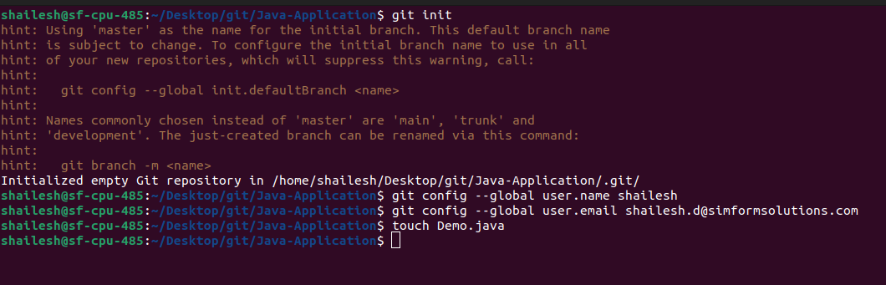

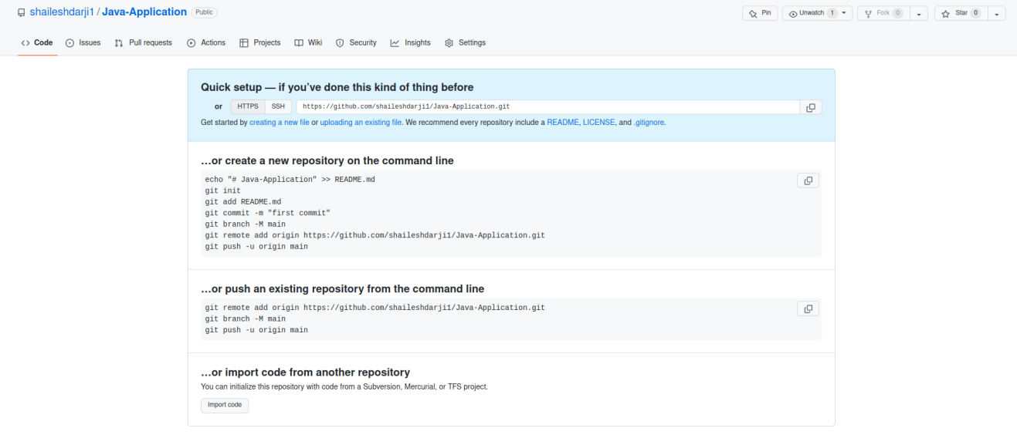

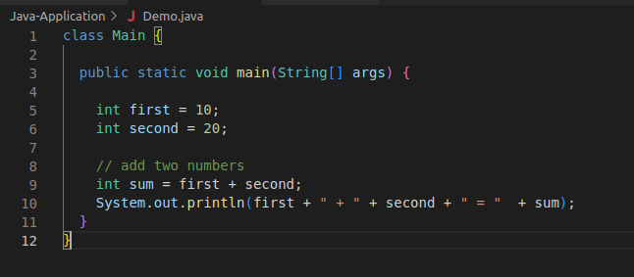

1. Commit application to GitHub account

* First check status using git status command
* Add Demo.java file into staging area using ‘git add Demo.java’ command
* After staging area commit this file using ‘commit -m “Inial commit” ’
* This process store repository at local area.
* Store repository at remote location first,we need to make connection using ‘git remote add origin https://token/[Repo-username][Repo-name]’
* Push our Repo at remote area using ‘git push -u origin master’
* This entire process for commit application to github account

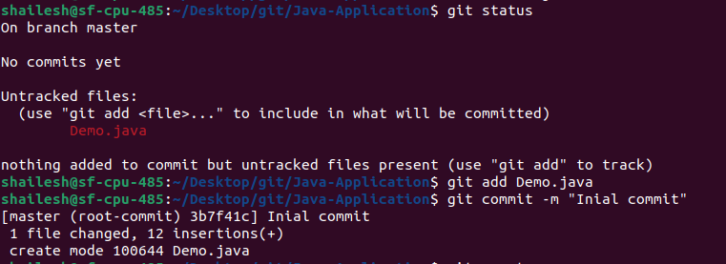



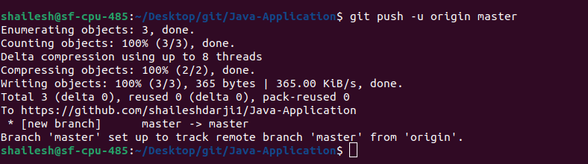

1. Create a branch and make changes and commit changes in the branch

* Check branch information using ‘git branch’
* Create new branch using ‘git branch new-branch’,here new branch name is new-branch.we can give any name to our new branch
* Switch to new branch using ‘git checkout new-branch’
* Make some changes on Demo.java file
* commit this file
* push our branch at remote area using ‘git push -u origin new-branch’

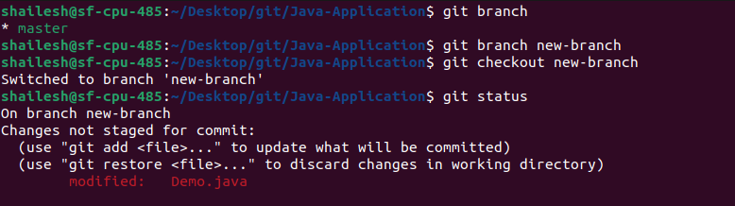

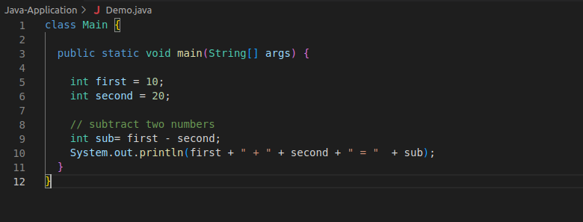

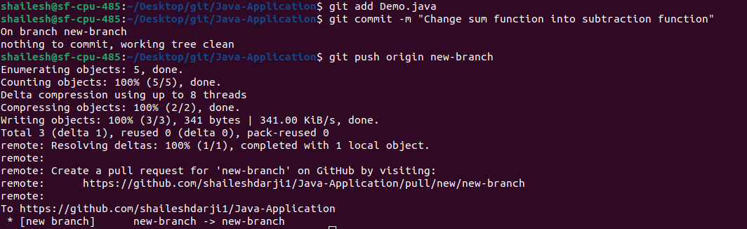

1. Create a pull request and merge it with the master branch

* After push new branch with changed file.We see notification in github ‘compare and pull request’ click on it
* Here see the option of create pull request,click on it(If you have to make some changes in message you can)
* Next Page show merge pull request,click on it and merge out new-branch with our master branch.
* At,We receive confimation message.

